STATISTICS FOR DATA ANALYTICS
APPLICATION ASSIGNMENT
50-Row E-Commerce / Retail Dataset
Use the provided Statistics_Data_Analytics_50_Row_Dataset.xlsx file. Apply the statistical concepts covered in the training and focus on interpretation, business reasoning and practical Data Analyst application.
Submitted by: Sowmiga Karthikeyan | Dataset: Dataset-1.xlsx (Dataset sheet, 50 rows, 12 columns) | Tools used: Python, pandas, NumPy, SciPy, matplotlib

1. Data Understanding
Using the Dataset sheet:
- Identify all numerical variables.
Answer: The numerical variables are Age, Order_Value, Items_Purchased, Discount_Percent, Delivery_Days, Customer_Rating and Marketing_Spend — 7 in total. These are the columns on which arithmetic such as mean, variance and correlation is meaningful.
- Identify all categorical variables.
Answer: The categorical variables are Customer_ID (a nominal identifier), Gender, Repeat_Customer, Payment_Mode and Order_Value_Band. Gender, Repeat_Customer and Payment_Mode are nominal; Order_Value_Band is ordinal (Low < Medium < High < Premium) because the categories have a natural order.
- Identify which numerical variables are discrete and which are continuous.
Answer: Discrete — Items_Purchased (1 to 12 whole items), Delivery_Days (1 to 7 whole days), Customer_Rating (integer scale 3 to 5 in this sample, ordinal), Discount_Percent (recorded only in fixed 5% steps: 0, 5, 10, 15, 20, 25, 30) and Age (recorded in completed years).
Continuous — Order_Value (₹850 to ₹30,000) and Marketing_Spend (₹500 to ₹6,777). Money can take any value on a scale, so it is measured rather than counted. Age is continuous in reality but is stored here as a rounded whole number, so it behaves as discrete in this file.
- Check for missing values.
Answer: There are no missing values. df.isnull().sum() returns 0 for all 12 columns across all 50 rows, so the dataset is 100% complete and no imputation or row deletion is required.
- Check for duplicate Customer_ID values.
Answer: No duplicates. df['Customer_ID'].duplicated().sum() = 0 and nunique() = 50, which matches the 50 rows. Each row is therefore one unique customer, so Customer_ID is a valid primary key.
- Identify the variable that represents customer spending, customer satisfaction, delivery performance and marketing investment.
Answer:
• Customer spending → Order_Value (the primary analysis variable, in ₹)
• Customer satisfaction → Customer_Rating (1–5 scale)
• Delivery performance → Delivery_Days (days taken to deliver)
• Marketing investment → Marketing_Spend (₹ spent on that customer)
- Which variables would you consider most useful for understanding customer behaviour? Give reasons.
Answer: The most useful variables for understanding customer behaviour are:
• Order_Value — it directly measures how much value each customer brings and is the base for segmentation, targeting and revenue forecasting.
• Repeat_Customer — it captures loyalty/retention, which is usually cheaper to grow than acquisition.
• Items_Purchased — it shows basket size and whether high spend comes from many items or a few expensive ones.
• Customer_Rating and Delivery_Days — together they explain satisfaction and the operational driver behind it; in this dataset rating falls as delivery days rise (r = −0.58).
• Discount_Percent and Marketing_Spend — they show what the business is investing to generate the order, so they connect behaviour to cost.
Age, Gender and Payment_Mode are useful as segmentation/profiling fields but they describe who the customer is rather than what the customer does.
Deliverable: Create a small data dictionary.
Column | Data Type | Variable Type | Business Meaning
Customer_ID | Text (object) | Categorical – nominal (identifier) | Unique ID for each customer; primary key, 50 unique values
Age | Integer | Numerical – discrete as recorded | Age of the customer in completed years (21–58); used for segmentation
Gender | Text (object) | Categorical – nominal | Gender of the customer (Female 25, Male 25)
Order_Value | Integer (₹) | Numerical – continuous | Value of the order in rupees (₹850–₹30,000); primary analysis variable / spending
Items_Purchased | Integer | Numerical – discrete | Number of items in the order (1–12); basket size
Discount_Percent | Integer (%) | Numerical – discrete (5% steps) | Discount applied to the order (0–30%); promotional intensity
Delivery_Days | Integer | Numerical – discrete | Days taken to deliver (1–7); delivery performance / operations KPI
Customer_Rating | Integer (1–5) | Numerical – discrete / ordinal | Satisfaction rating given by the customer (3–5 here); experience KPI
Marketing_Spend | Integer (₹) | Numerical – continuous | Marketing money attributed to that customer (₹500–₹6,777); marketing investment
Repeat_Customer | Text (Yes/No) | Categorical – nominal (binary) | Whether the customer has purchased before (16 Yes, 34 No); loyalty flag
Payment_Mode | Text (object) | Categorical – nominal | Payment method used (UPI 21, Debit Card 11, Net Banking 10, Credit Card 5, Cash 3)
Order_Value_Band | Text (object) | Categorical – ordinal | Pre-built spend band: Low < Medium < High < Premium (24 Medium, 13 High, 9 Low, 4 Premium)

2. Mean, Median & Mode
Use Order_Value.
- Calculate the mean.
Answer: Mean = ₹6,939.00 (total spend ₹346,950 ÷ 50 customers).
- Calculate the median.
Answer: Median = ₹5,500.00. With n = 50 the median is the average of the 25th and 26th ordered values (₹5,400 and ₹5,600), so (5,400 + 5,600) ÷ 2 = ₹5,500.
- Find the mode, if applicable.
Answer: There is no mode. Every one of the 50 Order_Value figures appears exactly once, so the distribution is amodal and the mode is not a useful measure here. (If a mode is needed for reporting, the modal band from Order_Value_Band is "Medium" with 24 of 50 customers.)
- Compare mean and median.
Answer: Mean (₹6,939) > Median (₹5,500), a gap of ₹1,439 or about 26% of the median. This is the classic signature of a right-skewed distribution: a small number of very large orders (₹15,500–₹30,000) pull the mean up, while the median stays with the bulk of customers. In fact 32 of 50 customers (64%) spend less than the mean.
- Which measure would you use to describe the typical customer order value?
Answer: I would use the median (₹5,500) to describe the typical customer order value.
- Explain why.
Answer: Because the mean is not resistant to extreme values and this distribution has four high outliers (skewness = +2.22). The mean of ₹6,939 describes almost nobody — it sits above 64% of customers. The median of ₹5,500 is a real middle point: half the customers spend less, half spend more, and it barely moves if the ₹30,000 order changes. "Typical" means representative, and the median is the representative figure.
Challenge:
If management asks, “How much does a typical customer spend?”, would you report the mean or median? Defend your answer.
Answer: I would report the median of ₹5,500 as the typical spend, and quote the mean of ₹6,939 separately as the average revenue per customer.
Defence: the two numbers answer two different questions. "How much does a typical customer spend?" is a question about the middle of the distribution, and the median answers it without being distorted by the four outlier orders. The mean answers a different question — total revenue ÷ customers — which is the right number for forecasting, budgeting and valuing the customer base (50 × ₹6,939 = ₹346,950 in actual revenue). Reporting only the mean would mislead management into designing offers around a ₹6,939 basket that 64% of customers never reach. So: median for "typical", mean for "total/planning", and always state both with the skew explained.

3. Variance & Standard Deviation
Use Order_Value.
- Calculate variance.
Answer: Sample variance (ddof = 1) = 29,681,866.33 ₹². Population variance (ddof = 0) = 29,088,229.00 ₹². I use the sample variance because these 50 customers are a sample of the company's customer base, not the whole population.
- Calculate standard deviation.
Answer: Sample standard deviation = √29,681,866.33 = ₹5,448.11 (population SD = ₹5,393.35).
- Is customer spending tightly concentrated or widely spread?
Answer: Widely spread. The SD of ₹5,448 is almost 79% of the mean of ₹6,939 (coefficient of variation = 78.5%). Anything above roughly 30% is already considered high variability, so customer spending here is very dispersed. The range confirms it: ₹850 to ₹30,000, a 35-fold difference between the smallest and largest order.
- What does the standard deviation tell you?
Answer: It says that a typical customer's order deviates from the ₹6,939 average by about ₹5,448 in either direction — i.e. the everyday spread of spending runs roughly from ₹1,500 to ₹12,400. Practically, it tells the business it does not have one homogeneous customer; it has a low-value majority plus a small high-value tail, so a single average-based strategy will fit neither group. Because the data is skewed, the SD is inflated by the outliers, so I would read it alongside the IQR (₹4,737), which describes the middle 50% more honestly.
- Why is standard deviation easier to communicate than variance?
Answer: Because the standard deviation is in the same unit as the data. Variance is 29,681,866 "rupees squared", which is not a quantity anyone can picture or compare with an average of ₹6,939. The SD converts it back to ₹5,448, which sits on the same scale as the mean, can be added to or subtracted from it, and can be explained to a manager in one sentence: "orders usually vary by about ₹5,400 around the average."
- Does a high standard deviation necessarily mean the data is bad?
Answer: No. A high standard deviation is information, not a defect — it means the data is diverse. Here it correctly reflects a real business fact: the company genuinely serves both ₹850 shoppers and ₹30,000 shoppers. That diversity is an opportunity for segmentation and premium targeting. A high SD is only a problem if it is caused by data-entry errors, mixed units or a broken measurement process — which is why the outliers must be investigated before any conclusion. Bad data is a data-quality question; high spread is a distribution question.
Business Question: If two stores have the same average order value but different standard deviations, what does that tell you?
Answer: It tells you the two stores have the same average but completely different customer profiles and different risk. Suppose both average ₹6,939. The low-SD store has customers clustered tightly around that value — predictable, homogeneous, easy to forecast inventory and staffing for, and its revenue does not depend on a few individuals. The high-SD store reaches the same average by mixing many small orders with a few very large ones — its revenue is concentrated in a handful of customers, so it is far more volatile and more exposed if one or two big buyers leave.
Actions differ too: the low-SD store should try to lift the whole base (upsell, bundles), while the high-SD store should protect its top customers with loyalty/key-account treatment and try to grow the long tail. It also changes the reporting: for the high-SD store the mean alone is misleading and the median and IQR should be reported with it.

4. Quartiles, Percentiles & IQR
Use Order_Value.
- Calculate Q1.
Answer: Q1 = ₹3,587.50 (the 25th percentile, using linear interpolation on the 50 sorted values).
- Calculate Q2.
Answer: Q2 = ₹5,500.00. Q2 is the same as the median and the 50th percentile.
- Calculate Q3.
Answer: Q3 = ₹8,325.00 (the 75th percentile).
- Calculate IQR.
Answer: IQR = Q3 − Q1 = 8,325.00 − 3,587.50 = ₹4,737.50.
- Calculate P25, P50, P75 and P90.
Answer: P25 = ₹3,587.50 · P50 = ₹5,500.00 · P75 = ₹8,325.00 · P90 = ₹12,650.00.
P25, P50 and P75 are identical to Q1, Q2 and Q3 by definition — quartiles are just the 25th, 50th and 75th percentiles.
- What does Q1 mean?
Answer: Q1 = ₹3,587.50 means 25% of customers spend ₹3,587.50 or less and the remaining 75% spend more. It is the upper edge of the lowest-spending quarter of the customer base — a useful cut-off for defining a "low-value" segment.
- What does Q3 mean?
Answer: Q3 = ₹8,325 means 75% of customers spend ₹8,325 or less and only the top 25% spend more. It is the entry point into the high-value quarter of the base.
- What percentage of observations lie below Q3?
Answer: 75% of the observations lie below Q3 (and 25% lie above it). With n = 50 that is about 37–38 customers below and 12–13 above.
- What does P90 mean?
Answer: P90 = ₹12,650 means 90% of customers spend ₹12,650 or less, and only the top 10% spend more than that. It is the threshold that defines the top decile of spenders.
- What does IQR tell us about customer spending?
Answer: The IQR of ₹4,737.50 is the spread of the middle 50% of customers — from ₹3,587.50 to ₹8,325. It says that the typical, everyday customer sits in a fairly narrow ₹4,700-wide band, even though the full range is ₹850–₹30,000. That is the key insight: the overall SD (₹5,448) looks larger than the IQR (₹4,738) because the SD is inflated by four extreme orders, while the IQR ignores them completely. The IQR is therefore the more honest measure of spread for this skewed distribution, and it is also the basis for the outlier boundaries in the next section.
Business Challenge: The marketing team wants to target the top 10% of customers based on spending. Which percentile would you use? Explain how you would identify those customers.
Answer: I would use the 90th percentile (P90), because "top 10%" is by definition everything above the 90th percentile.
How I would identify them:
1. Compute the cut-off: threshold = np.percentile(df['Order_Value'], 90) = ₹12,650.
2. Filter the customers: top10 = df[df['Order_Value'] >= 12650].
3. That returns 5 customers — C004 (₹30,000), C044 (₹22,000), C007 (₹18,000), C009 (₹15,500) and C008 (₹14,000). They alone account for ₹99,500, i.e. about 29% of the total revenue of ₹346,950.
4. Hand marketing that list with their Payment_Mode, Repeat_Customer and Items_Purchased attached so the campaign can be personalised.
Why percentile and not a fixed rupee value: a percentile is relative, so the definition of "top 10%" automatically updates as spending patterns change, and it works the same way on 50 rows or on the full 50,000-customer base. Note that 3 of these 5 are already repeat customers, so this segment is about retention and premium service rather than discounting.

5. Outlier Investigation
Use Order_Value and apply the IQR method.
- Calculate Q1, Q3 and IQR.
Answer: Q1 = ₹3,587.50, Q3 = ₹8,325.00, IQR = 8,325.00 − 3,587.50 = ₹4,737.50.
- Calculate the lower boundary and upper boundary.
Answer: 1.5 × IQR = 1.5 × 4,737.50 = ₹7,106.25.
Lower boundary = Q1 − 1.5 × IQR = 3,587.50 − 7,106.25 = −₹3,518.75.
Upper boundary = Q3 + 1.5 × IQR = 8,325.00 + 7,106.25 = ₹15,431.25.
The lower boundary is negative, so no order can fall below it — a further sign of right skew. Only the upper side can produce outliers.
- Identify potential outliers.
Answer: Four potential high-side outliers, all above ₹15,431.25:
• C004 — ₹30,000, 12 items, Repeat = Yes, Marketing_Spend ₹6,777, Debit Card
• C044 — ₹22,000, 12 items, Repeat = Yes, Marketing_Spend ₹5,287, Net Banking
• C007 — ₹18,000, 12 items, Repeat = Yes, Marketing_Spend ₹5,172, Debit Card
• C009 — ₹15,500, 12 items, Repeat = No, Marketing_Spend ₹4,913, Credit Card
No low-side outliers exist. The 4 flagged rows are 8% of the dataset and contribute ₹85,500, i.e. 24.6% of total revenue.
- Are these observations necessarily errors?
Answer: No. Nothing here looks like an error. All four bought 12 items — the maximum in the dataset — so a high order value is exactly what you would expect; value and basket size are internally consistent. All four also received the highest marketing spend (₹4,913–₹6,777 vs. a dataset average of ₹2,508), and three of the four are repeat customers. These are statistical outliers but genuine, plausible, high-value business records. A true error would look different: an order of ₹3,000,000, a negative value, 12 items with a value of ₹200, or a value that contradicts the Order_Value_Band field.
- Give possible business reasons for a very high order.
Answer: Plausible business reasons for a very high order:
• Bulk or family purchase — one basket covering many people or a full-home order (all four bought the maximum 12 items).
• Premium or big-ticket category — electronics, appliances or furniture instead of everyday items.
• Corporate / B2B or reseller buying through a retail account.
• Festival, wedding or seasonal event purchase (Diwali, back-to-school, wedding shopping).
• A high-value loyal customer responding to targeted marketing — these four received the highest Marketing_Spend in the file.
• Free-delivery or spend-threshold offer that encouraged basket consolidation.
• Genuinely wealthy or VIP segment customer whose normal basket is simply larger.
- Calculate the mean before investigating the outlier.
Answer: Mean before any exclusion = ₹6,939.00 (all 50 customers).
- Recalculate the mean after excluding the potential outlier.
Answer: Excluding only the single most extreme observation (C004, ₹30,000): mean of the remaining 49 customers = ₹6,468.37.
Excluding all four flagged outliers (C004, C044, C007, C009): mean of the remaining 46 customers = ₹5,683.70, with SD falling from ₹5,448.11 to ₹3,082.73 and the median moving only slightly, from ₹5,500 to ₹5,125.
- How much did the mean change?
Answer: Removing just C004 moved the mean by ₹470.63, from ₹6,939.00 to ₹6,468.37 — a fall of 6.8% caused by 1 row out of 50. Removing all four outliers moved it by ₹1,255.30, from ₹6,939.00 to ₹5,683.70 — a fall of 18.1%. Meanwhile the median moved by only ₹375 (6.8% → in fact from ₹5,500 to ₹5,125), and the SD dropped by 43%.
Interpretation: the mean is highly sensitive to a handful of records while the median is stable. That is precisely why the median is the safer headline measure for this dataset — and note that after removing the outliers the mean (₹5,683.70) finally comes close to the median (₹5,125), confirming that the skew was driven by those four orders.
Important Question: Should a Data Analyst automatically delete an outlier? Explain your answer.
Answer: No — never automatically. An outlier is a flag for investigation, not a licence to delete.
The correct process is: detect (IQR or z-score) → verify against source systems and related fields → classify → then decide.
• If it is a genuine data error (typo, wrong unit, duplicate, corrupted feed) → correct it if possible, otherwise exclude it and document the reason.
• If it is a genuine but extreme observation — which is the case for all four rows here — keep it. Deleting it would destroy real revenue information, understate the true customer base and hide the most valuable customers the company has. Those 4 rows are 24.6% of revenue; dropping them would make the business look 25% smaller.
Instead of deleting, an analyst should: report median and IQR alongside mean and SD, show results both with and without the outliers so the impact is transparent, segment the high-value customers as their own group rather than averaging them away, and use robust or log-transformed measures if modelling is required. Silently deleting inconvenient data points is also an ethical issue — it changes the story management is told.

6. Histogram & Boxplot
Create a histogram and a boxplot for Order_Value.
Answer: Both charts were produced in Python with matplotlib on the 50 Order_Value observations (10 bins for the histogram; the boxplot uses the default 1.5 × IQR whisker rule).
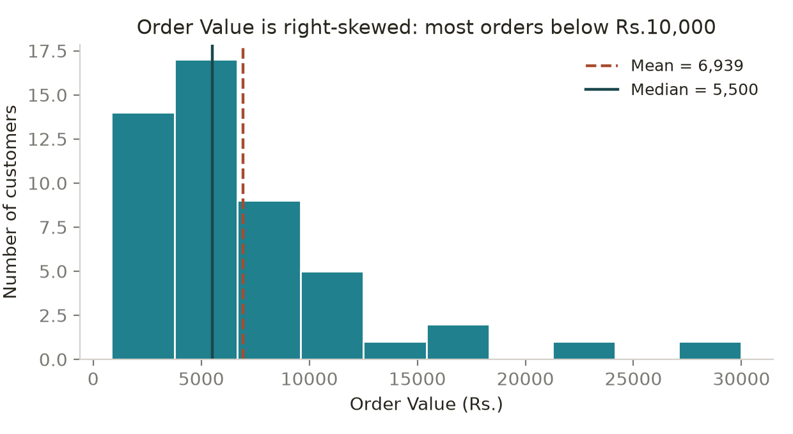
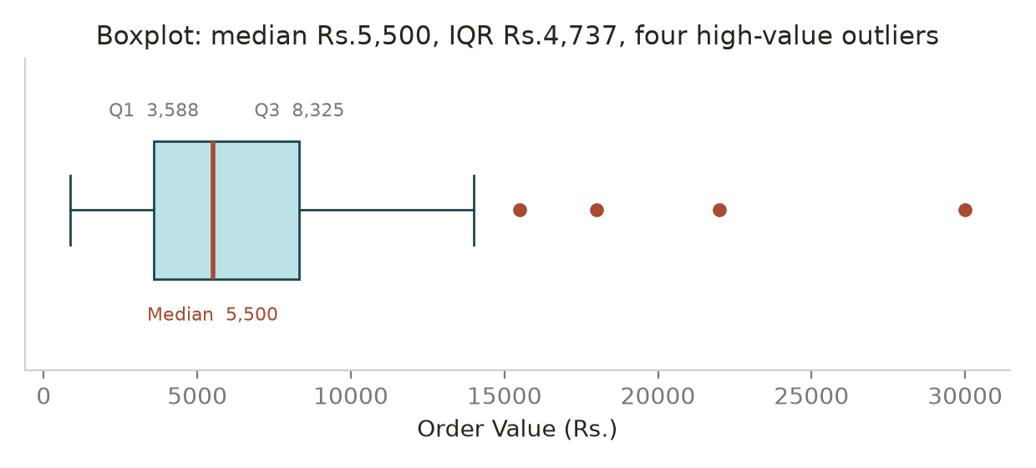
Analyze the histogram:
- What does the shape look like?
Answer: The shape is a single-peaked (unimodal) distribution with a tall block on the left and a long thin tail stretching to the right — the classic right-skewed / positively skewed "income-type" shape. It is nothing like a symmetric bell curve.
- Where are most orders concentrated?
Answer: Most orders are concentrated in the low range. 22 of 50 customers (44%) fall below ₹5,000 and 41 of 50 (82%) fall below ₹10,000; the tallest bar sits between roughly ₹3,000 and ₹6,000. The middle 50% of all customers lie between ₹3,587.50 and ₹8,325.
- Is the distribution symmetric?
Answer: No, it is clearly not symmetric. In a symmetric distribution the mean and median coincide; here the mean (₹6,939) sits ₹1,439 above the median (₹5,500), and 64% of observations fall below the mean. The left side stops at ₹850 while the right side runs out to ₹30,000, so the two halves are not mirror images.
- Does it appear right-skewed or left-skewed?
Answer: Right-skewed (positively skewed). The long tail points towards the high values, the measured skewness is +2.22, and the ordering mean > median > (no mode) confirms it. Only 5 customers sit above ₹12,650 but they stretch the axis all the way to ₹30,000.
- Are there extreme values?
Answer: Yes. There are isolated bars far to the right of the main body — the ₹15,500, ₹18,000, ₹22,000 and ₹30,000 orders. There is a visible gap between about ₹15,500 and ₹30,000 with almost nothing in between, which is a strong visual signal of extreme values rather than a smooth tail.
Analyze the boxplot:
- Identify the median.
Answer: The median is the line inside the box, at ₹5,500. It is noticeably left of centre within the box, which itself indicates right skew.
- Identify Q1 and Q3.
Answer: Q1 is the left edge of the box at ₹3,587.50 and Q3 is the right edge at ₹8,325.00.
- Identify the IQR.
Answer: The IQR is the width of the box itself: ₹8,325.00 − ₹3,587.50 = ₹4,737.50. The distance from Q1 to the median (₹1,912.50) is smaller than from the median to Q3 (₹2,825), again showing the skew.
- Identify potential outliers.
Answer: Four points plotted individually beyond the right whisker — ₹15,500 (C009), ₹18,000 (C007), ₹22,000 (C044) and ₹30,000 (C004). The right whisker ends at ₹14,000, the largest observation still inside the ₹15,431.25 upper boundary. The left whisker reaches the minimum of ₹850, and there are no outliers on the low side.
Business Question: Which visualization would you use to quickly identify potential outliers? Why?
Answer: The boxplot, for a quick outlier check. It applies the 1.5 × IQR rule automatically and plots each offending observation as its own marker, so the count and position of outliers can be read in one second — here, four dots on the right — without choosing bin widths. A histogram only hints at extremes through short or isolated bars, and its appearance changes with the number of bins, so two analysts can reach different conclusions from the same data.
In practice I would show both: the boxplot to identify and count outliers and to read the five-number summary, and the histogram to show the shape of the distribution and where the mass of customers sits, which the boxplot hides. The boxplot answers "are there extreme customers?"; the histogram answers "what does the typical customer look like?"

7. Skewness & Kurtosis Awareness
- Determine whether the Order_Value distribution appears approximately symmetric, right-skewed or left-skewed.
Answer: Right-skewed (positively skewed). Measured skewness = +2.22 (pandas .skew(), sample-adjusted; scipy.stats.skew gives +2.15). Any value beyond about ±1 is treated as substantial skew, so +2.22 is strong right skew. It is confirmed by mean (₹6,939) > median (₹5,500) and by the long right tail in the histogram.
- Explain what the skewness tells you about customer spending.
Answer: It tells me that most customers spend modest amounts while a small minority spend very large amounts, and it is that minority that drags the average upward. Concretely: 64% of customers spend below the mean, and the top 5 customers (10% of the base) generate about 29% of total revenue.
Business consequences: (a) the mean order value is not a target most customers will ever hit, so the median should be used for "typical customer" reporting; (b) revenue is concentrated, so losing one or two top customers hurts disproportionately; (c) the base should be segmented rather than treated as one average customer; and (d) any statistical technique that assumes normality should be used with care, or the variable should be log-transformed first.
- Check the kurtosis using Python.
Answer: Checked in Python.
import pandas as pd; from scipy.stats import kurtosis
df['Order_Value'].kurtosis() → 6.39 (excess kurtosis, sample-adjusted)
kurtosis(df['Order_Value']) → 5.65 (excess, Fisher definition)
kurtosis(df['Order_Value'], fisher=False) → 8.65 (raw / Pearson kurtosis)
A normal distribution has excess kurtosis = 0 (raw kurtosis = 3), so this distribution is strongly leptokurtic.
- State whether the distribution shows relatively heavier or lighter tails compared with a normal distribution.
Answer: Heavier tails than a normal distribution. Excess kurtosis of +6.39 is far above 0, meaning extreme values occur much more often than a normal curve would predict. Under a normal distribution with mean ₹6,939 and SD ₹5,448, a ₹30,000 order is about 4.2 SDs above the mean — something you would expect roughly once in 75,000 observations, yet it appears once in 50 here. Practically: very large orders are a normal feature of this business, not freak events, so the company should plan for them (stock, credit, fraud checks, VIP handling) rather than treat each one as an anomaly.
- Do not focus on mathematical derivation.
Answer: Noted — no derivation attempted. The measures are used only as diagnostic indicators: skewness ≈ +2.22 tells me which summary statistic to trust (median over mean) and kurtosis ≈ +6.39 tells me to expect occasional extreme orders and to check outliers rather than assume normality. The interpretation, not the formula, is what drives the business decision.
Business Interpretation: Why might an e-commerce company naturally have a right-skewed order-value distribution?
Answer: Because e-commerce spending has a hard floor but no ceiling. An order cannot be less than zero (in practice not below the price of one cheap item — ₹850 here), yet there is nothing stopping a customer from spending ₹30,000 or ₹300,000. That asymmetry alone forces a right tail.
On top of that: (1) most baskets are small, everyday, single-item purchases while a few are big-ticket electronics, appliances or furniture; (2) catalogues span a huge price range, so one platform serves ₹200 items and ₹80,000 items; (3) bulk, family, festival, wedding and B2B/reseller orders create occasional very large baskets; (4) customer purchasing power itself is right-skewed, mirroring the income distribution; and (5) a small group of loyal VIP customers buys repeatedly and in volume — the familiar Pareto pattern where roughly the top 10–20% of customers drive 30–50% of revenue, which is exactly what this dataset shows.

8. Probability
Using the dataset, calculate:
- Probability that a randomly selected customer is a Repeat Customer.
Answer: P(Repeat Customer) = 16 / 50 = 0.32, i.e. 32%.
Business interpretation: roughly one in three customers has bought before, so about two-thirds of the base is still first-time. There is a clear retention gap — most e-commerce businesses aim higher — but also clear upside, because repeat customers in this dataset spend an average of ₹10,466 against ₹5,279 for non-repeat customers, almost double. Converting even a small share of the 34 one-time buyers into repeat buyers would lift revenue more cheaply than acquiring new customers.
- Probability that an order has a discount greater than 20%.
Answer: P(Discount > 20%) = 14 / 50 = 0.28, i.e. 28%. (Only Discount_Percent values of 25% and 30% qualify. If the question were read as "20% or more", it would be 22 / 50 = 0.44.)
Business interpretation: more than a quarter of all orders carry a deep discount above 20%, which is a significant margin cost. It is worth checking whether that spend is buying anything: in this dataset the correlation between Discount_Percent and Order_Value is −0.07, effectively zero, so heavier discounting is not associated with larger baskets. That suggests the deep discounts may be subsidising purchases that would have happened anyway, and the discount policy should be tested rather than assumed to work.
- Probability that an order takes more than 5 days to deliver.
Answer: P(Delivery_Days > 5) = 5 / 50 = 0.10, i.e. 10%. (Read as "5 days or more" it would be 12 / 50 = 0.24.)
Business interpretation: one in ten orders takes more than 5 days, so 90% of deliveries are within 5 days — reasonable but not excellent. The concern is the link to satisfaction: average rating falls from 5.0 at 1 day and 4.6 at 2 days to 3.0 at 6 days, and Delivery_Days correlates −0.58 with Customer_Rating. At a 50,000-customer scale a 10% rate means about 5,000 slow deliveries and a measurable drag on ratings, reviews and repeat purchase, so the tail of slow shipments is the priority for the operations team.
For each probability, provide the numerical answer and a clear business interpretation.
Answer: Each probability above is reported with its numerical value and its business meaning. Method note: every probability here is an empirical (relative-frequency) probability — favourable cases ÷ 50 total cases — because it is estimated from observed data rather than from a theoretical model. With only 50 rows these estimates carry meaningful sampling error (the 95% confidence interval for the 32% repeat rate is roughly 19%–45%), so they should be treated as indicative and re-checked on the full customer base before large decisions are taken.

9. Conditional Probability
Calculate the probability that a customer is a Repeat Customer given that their Order_Value is greater than ₹5,000.
Answer: P(Repeat = Yes | Order_Value > ₹5,000) = 13 / 28 = 0.4643, i.e. about 46.4%.
Working: 28 of the 50 customers have Order_Value > ₹5,000; of those 28, 13 are repeat customers. Using the formula P(A|B) = P(A ∩ B) / P(B) = (13/50) ÷ (28/50) = 0.26 / 0.56 = 0.4643.
- Calculate the overall probability of being a Repeat Customer.
Answer: P(Repeat = Yes) = 16 / 50 = 0.32, i.e. 32%.
- Compare the two probabilities.
Answer: Conditional 46.4% vs. overall 32.0% — a difference of 14.4 percentage points, which is a relative increase of about 45%. For contrast, among customers spending ₹5,000 or less the repeat rate is only 3 / 22 = 13.6%, so the gap between the two spending groups is more than threefold.
- Which probability is higher?
Answer: The conditional probability is higher: P(Repeat | Order_Value > ₹5,000) = 46.4% > P(Repeat) = 32%.
- What does the difference suggest?
Answer: It suggests that spending level and repeat status are not independent — they are positively associated. If they were independent, the conditional probability would equal the overall 32%. Knowing that a customer spends above ₹5,000 makes it noticeably more likely that they are a repeat customer, so Order_Value carries useful predictive information about loyalty (and vice versa). Operationally, high-spending customers are a richer pool for loyalty programmes, and repeat customers are worth protecting because they are concentrated at the high-value end.
- Does this prove that high spending causes repeat purchases?
Answer: No. This is association, not causation. The calculation only shows that the two attributes occur together more often than chance would predict; it says nothing about direction or mechanism.
Three reasons it cannot be a causal claim: (1) reverse causality is at least as plausible — repeat customers may spend more because they already trust the brand, know the catalogue and buy across more categories, so loyalty causes spend rather than the other way round; (2) confounding — Marketing_Spend is high for exactly these customers (r = 0.86 with Order_Value), so marketing attention, better service or category mix could be driving both; (3) it is observational, cross-sectional data on only 50 customers, with no time ordering and no control group. Establishing causation would need a randomised experiment or a longitudinal design that observes spending before repeat behaviour.
- Give one possible factor other than Order_Value that could influence repeat purchasing.
Answer: Delivery experience — Delivery_Days and the resulting Customer_Rating. A customer whose order arrives in 1–2 days rates the company 4.6–5.0 on average, while a 6-day delivery averages 3.0, and delivery days correlate −0.58 with rating. A satisfied customer is far more likely to come back regardless of how much they spent, so service quality is a strong alternative driver of repeat purchasing.
Other plausible factors: product category and replenishment cycle (consumables naturally repeat), marketing and retargeting intensity, loyalty programme membership, discount and offer exposure, returns and support experience, payment convenience, and simply how long the customer has been on the platform (tenure).

10. Random Variables
- Identify two discrete random variables from the dataset.
Answer: Two discrete random variables: Items_Purchased (number of items in the order) and Delivery_Days (number of days taken to deliver). Customer_Rating is a third example.
- Identify two continuous random variables from the dataset.
Answer: Two continuous random variables: Order_Value (order value in ₹) and Marketing_Spend (marketing rupees attributed to the customer).
- Explain why you classified each variable that way.
Answer:
• Items_Purchased — discrete because it is a count. It takes only whole-number values (1 to 12 in this dataset); 4.7 items cannot exist, and the values are separated by clear gaps.
• Delivery_Days — discrete as recorded. The dataset stores completed days as integers 1 to 7. Time is continuous in principle, but the measurement here is a countable number of days, so it is treated as discrete.
• Order_Value — continuous because it is a measured amount of money on a scale, not a count. Between ₹4,000 and ₹5,000 any intermediate value is possible (₹4,375.50), so the variable is limited only by the precision of recording, not by its nature. The values in this file happen to be rounded, but the underlying quantity is continuous.
• Marketing_Spend — continuous for the same reason: it is an amount of money that can in principle take any value in its range (₹500 to ₹6,777).
Rule of thumb used: if you count it, it is discrete; if you measure it, it is continuous.
- Suppose the company randomly selects one customer. Define X = Order_Value of the selected customer. Explain what possible values X can take.
Answer: X = Order_Value of one randomly selected customer is a continuous random variable. In principle X can take any positive real value from the smallest possible purchase price up to the highest basket the customer could build — theoretically 0 < X < ∞, with a hard floor at zero because an order value cannot be negative.
Empirically, in this dataset X can take any one of the 50 observed values from ₹850 (C048's ₹1,200 is the second lowest; C041 at ₹850 is the minimum) up to ₹30,000 (C004), each with probability 1/50 = 0.02 since all 50 values are distinct. From that empirical distribution: E(X) = ₹6,939, median = ₹5,500, SD = ₹5,448, P(X > ₹12,650) = 0.10 and P(X ≤ ₹5,000) = 22/50 = 0.44. The distribution of X is right-skewed, so low and mid values are far more likely than high ones.
- Define Y = Items_Purchased. Explain how Y differs from X as a random variable.
Answer: Y = Items_Purchased is a discrete random variable, and it differs from X in four ways.
1. Type of value: Y takes only isolated whole numbers (1, 2, 3, … 12) while X takes any value on a continuous rupee scale. P(Y = 5) is a genuine, non-zero probability (5 of 50 customers, 0.10), whereas for a truly continuous X the probability of any exact single value is effectively zero — only intervals such as P(4,000 < X < 6,000) are meaningful.
2. Distribution tool: Y is described by a probability mass function (a bar for each possible count); X is described by a probability density function, where probability is the area under the curve.
3. Range and scale: Y is bounded and narrow (1–12, range 12); X is effectively unbounded above and spans ₹850–₹30,000. So Y is much less dispersed in relative terms.
4. Business role: Y measures basket size (an operational, count-based quantity affecting picking, packing and logistics); X measures revenue (a financial quantity). They are strongly related — the four largest orders all had Y = 12 — but they answer different questions, and only X can be summed directly into revenue.

11. Sampling & Sampling Bias
Business Scenario: The company has 50,000 customers but can survey only 500 customers.
- How would you select the sample?
Answer: I would draw a probability sample of 500 from the full frame of 50,000 customers (a 1% sample). Steps: (1) define the target population and build a clean sampling frame from the CRM, de-duplicated on Customer_ID and covering all customers, not just recent buyers; (2) decide the variables that matter for representativeness — Order_Value_Band, Repeat_Customer, region and acquisition channel; (3) split the frame into strata on those variables; (4) allocate the 500 across strata in proportion to their share of the population — on this dataset's proportions that would be about 90 Low, 240 Medium, 130 High and 40 Premium; (5) inside each stratum select customers with a random number generator (np.random.default_rng().choice) so every member has a known, non-zero chance of selection; (6) fix a random seed and document it for reproducibility; (7) track the response rate and apply post-stratification weights if some strata under-respond.
- Would you use probability or non-probability sampling?
Answer: Probability sampling. Because every customer has a known, non-zero chance of being selected, probability sampling is the only approach that lets me generalise from the 500 to the 50,000, quantify sampling error, and compute confidence intervals. Non-probability sampling (convenience, quota, judgement) gives no basis for statistical inference and carries unmeasurable selection bias, so it would only be acceptable for exploratory or qualitative work, not for a survey management intends to act on.
- Which sampling technique would you recommend?
Answer: Stratified random sampling, with Order_Value_Band (Low / Medium / High / Premium) as the primary stratifying variable and Repeat_Customer as a secondary one. Simple random sampling would be an acceptable fallback, and systematic sampling (every 100th customer from a randomly ordered list) is a practical alternative.
- Why?
Answer: Because spending in this business is heavily right-skewed and the high-value group is small but commercially critical. Premium customers are only about 8% of the base (4 of 50 here) yet they drive roughly a quarter of revenue. A simple random sample of 500 would be expected to catch about 40 of them, but by chance could catch far fewer, and the survey would then under-represent exactly the customers whose opinion matters most. Stratifying guarantees each band appears in the correct proportion, removes that source of luck, and also reduces the standard error for the same sample size because it eliminates between-stratum variation. As a bonus it allows reliable reporting within each segment, not just overall — and if needed, high-value strata can be deliberately over-sampled and corrected later with weights.
- What could go wrong if the sample is not representative?
Answer: If the sample is not representative, every number produced from it is biased, and the bias does not shrink as the sample gets bigger — a large biased sample is simply confidently wrong.
Concrete consequences: (1) point estimates are off — over-sampling premium customers would push the average order value well above the true ₹6,939 and lead to inflated revenue forecasts and inventory orders; (2) satisfaction is misread — surveying mainly happy or mainly complaining customers gives a rating that is not the company's real 4.12; (3) confidence intervals and significance tests become invalid because they only account for random error, not selection error; (4) segments are missed entirely, so problems affecting a whole group (say slow delivery in one region) stay invisible; (5) budgets, pricing and product decisions are then made on the wrong picture, wasting money and damaging credibility when reality diverges; and (6) the error is often undetectable after the fact, because there is no way to know from the sample alone what the non-respondents would have said. Cost of prevention is small; cost of a biased survey is a wrong strategy.
Scenario 2: The company asks only customers who purchased during the last 7 days to complete a satisfaction survey.
- Is this necessarily representative of all customers?
Answer: No, it is not representative of all customers. It is a sample of recent buyers only, which is a subgroup selected on the very behaviour being studied, not a random slice of the base.
- Who might be missing?
Answer: Missing groups include: customers who bought earlier but not in the last 7 days — the large majority of the 50,000; lapsed and churned customers, who are precisely the people whose dissatisfaction the company most needs to hear; seasonal or occasional buyers with long purchase cycles; customers of slow-moving or high-value categories bought once a year; customers who abandoned a cart or never purchased at all; customers whose orders from the last 7 days have not yet been delivered, so they cannot judge delivery; and, if the survey is emailed or in-app, anyone who does not read email or use the app. In effect the survey hears from the most active, most recently engaged and most satisfied part of the base.
- What type of bias could occur?
Answer: Several biases overlap here:
• Selection / coverage bias — the sampling frame (last 7 days' buyers) does not match the target population (all customers), so part of the population has zero chance of selection.
• Survivorship bias — only customers still buying are heard; those who left are structurally excluded, so satisfaction will be overstated.
• Recency / time-period bias — a single 7-day window captures whatever was happening that week (a festival sale, a stock-out, a courier strike) and treats it as normal.
• Non-response and self-selection bias — among those invited, customers with very good or very bad experiences answer most, producing a polarised picture.
• Voluntary response bias if participation is optional and unincentivised.
Net effect: the measured satisfaction score will almost certainly be biased upward, and management will believe the customer experience is better than it is.
- How would you improve the sampling approach?
Answer: Improvements I would make: (1) draw the sample from the entire customer base of 50,000, not from a 7-day purchase window; (2) use stratified random sampling on Order_Value_Band, Repeat_Customer, recency and region so every segment is proportionally represented; (3) include lapsed and churned customers deliberately, and run a short separate win-back survey for them; (4) widen the window to 3–12 months, or run a continuous rolling survey and report a moving average so no single week dominates; (5) trigger the survey a fixed number of days after delivery rather than after purchase, so every respondent has actually experienced the service; (6) use several contact channels — email, SMS, app, phone — to reduce coverage bias; (7) send reminders and offer a small neutral incentive to lift the response rate and cut non-response bias; (8) keep the questionnaire short and neutrally worded to avoid leading answers; (9) measure the response rate by stratum and apply post-stratification weights where a stratum under-responds; and (10) profile a subset of non-respondents to test whether they differ from respondents, and report the sampling method, dates and margin of error alongside every result.
Scenario 3: The company selects 500 customers simply because they are easiest to contact. Identify the sampling approach and discuss its limitation.
Answer: This is convenience sampling — a non-probability method in which units are chosen simply because they are easy to reach (customers with a valid phone number, those who answer quickly, those in the office's own city, or the first 500 in the database).
Limitations: selection probabilities are unknown and unequal, so the results cannot legitimately be generalised to the 50,000 customers and no valid confidence interval or margin of error can be computed. The bias is systematic and unmeasurable, and it does not disappear with a larger sample — surveying 5,000 easy-to-contact customers would only make a wrong estimate look more precise. "Easiest to contact" is itself correlated with the things being measured: reachable customers tend to be more digitally engaged, more recently active, more urban and more loyal, so satisfaction and repeat rates will be overstated while hard-to-reach, rural, lapsed and dissatisfied customers are silently excluded. The findings are also not reproducible, since another analyst's "easiest" 500 would be a different group.
When it is acceptable: early exploratory work, questionnaire pre-testing, pilot studies or qualitative insight — provided the report states clearly that the sample is non-probability and the numbers are indicative only. For a decision-grade satisfaction measure, stratified random sampling should be used instead.

12. NumPy Sampling Simulation
- Randomly select 10 customers from the 50-row dataset.
Answer:
import numpy as np
rng = np.random.default_rng(7)
sample = rng.choice(df['Order_Value'].to_numpy(), size=10, replace=False)
One such sample of 10: [4150, 7800, 2600, 7200, 1450, 2750, 4600, 4750, 8400, 4000]. Sampling is without replacement so no customer is picked twice, and a seed is set so the result is reproducible.
- Calculate the sample mean of Order_Value.
Answer: sample.mean() = ₹4,770.00 for the sample above. That is ₹2,169 below the true population mean of ₹6,939 — a 31% underestimate — purely because this particular draw happened to miss all four high-value customers. This single number is the sampling error, and it is exactly why one sample is never enough.
- Repeat the process 100 times.
Answer: The process was repeated 100 times.
rng = np.random.default_rng(42)
means = np.array([rng.choice(values, 10, replace=False).mean() for _ in range(100)])
- For each sample, select 10 customers randomly, calculate the sample mean and store the result.
Answer: Each of the 100 iterations drew a fresh random sample of 10 customers, computed that sample's mean Order_Value and appended it to the results array, giving 100 stored sample means. Summary of the 100 means: average of the sample means = ₹6,770.55 (very close to the true mean of ₹6,939), standard deviation of the sample means (the standard error) = ₹1,649.49, minimum = ₹3,540.00, maximum = ₹11,550.00. This distribution of sample means is called the sampling distribution of the mean.
- Create a histogram of the 100 sample means.
Answer: Histogram of the 100 sample means for n = 10, shown next to the same simulation at n = 25 for comparison. The dashed line marks the true population mean of ₹6,939.
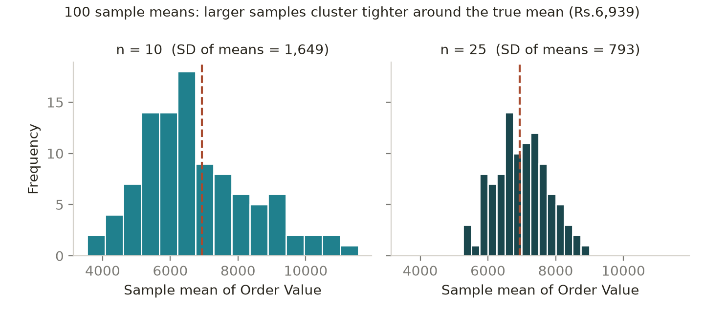
The n = 10 distribution is wide and still slightly right-skewed (inherited from the parent distribution), while the n = 25 distribution is visibly narrower and closer to a bell shape — a practical demonstration of the Central Limit Theorem.
- Are all sample means identical?
Answer: No. 95 of the 100 sample means are distinct, and they range from ₹3,540 to ₹11,550 — a spread of ₹8,010, wider than the population mean itself. Only a few repeat, and none of them is exactly the true mean of ₹6,939.
- Why do they differ?
Answer: They differ because of sampling variability (sampling error) — each sample contains a different random subset of 10 of the 50 customers, and the population itself is highly dispersed (SD = ₹5,448, right-skewed). The decisive factor is whether a draw happens to include one of the four outliers: a sample containing C004's ₹30,000 order is pulled far above the true mean, while a sample of only low spenders falls far below it. This is random, not a mistake — it is the natural consequence of estimating a population value from part of the data. Theory matches the simulation: the expected standard error is σ/√n = 5,448/√10 = ₹1,723, and the observed SD of the 100 means was ₹1,649. Reassuringly, the mean of all 100 sample means (₹6,770) is close to the population mean, showing the sample mean is an unbiased estimator even though any single sample can be well off.
- What happens if you increase the sample size from 10 to 25?
Answer: The sample means become much less variable and cluster far more tightly around the true mean. Repeating the simulation with n = 25: SD of the 100 sample means falls from ₹1,649.49 to ₹792.77 — a 52% reduction — and the range narrows from ₹3,540–₹11,550 to ₹5,256–₹8,998. The average of the sample means also lands closer to the truth (₹6,984 vs. the true ₹6,939), and the histogram becomes more symmetric and bell-shaped. This follows the standard-error formula SE = σ/√n: 5,448/√10 = ₹1,723 against 5,448/√25 = ₹1,090. Note the √n, not n — quadrupling the sample size only halves the error, so precision gets progressively more expensive.
- Which sample size would generally produce more stable sample means?
Answer: n = 25 produces more stable sample means. Its standard error is roughly half that of n = 10 (₹793 vs. ₹1,649 observed), so any single sample of 25 is far more likely to land near the true mean, and by the Central Limit Theorem its sampling distribution is closer to normal, which makes confidence intervals and significance tests more trustworthy. Larger samples also dilute the influence of any one outlier.
Practical caveat: larger samples cost more time and money, and the benefit grows only with √n, so in the real 50,000-customer survey the right answer is to choose n from a target margin of error rather than to maximise it — and to remember that a bigger sample fixes random error, not bias from a poor sampling method.

13. NumPy Implementation
Using NumPy, calculate the following for Order_Value:
Answer: All values below were computed with NumPy on values = df['Order_Value'].to_numpy(), n = 50.
import numpy as np
values = df['Order_Value'].to_numpy()
- Mean
np.mean(values) = 6939.00
- Median
np.median(values) = 5500.00
- Variance
np.var(values, ddof=1) = 29,681,866.33 (sample); np.var(values) = 29,088,229.00 (population, NumPy's default ddof = 0)
- Standard deviation
np.std(values, ddof=1) = 5448.11 (sample); np.std(values) = 5393.35 (population)
- Minimum
np.min(values) = 850 (customer C041)
- Maximum
np.max(values) = 30000 (customer C004)
- 25th percentile
np.percentile(values, 25) = 3587.50
- 50th percentile
np.percentile(values, 50) = 5500.00 (equals the median)
- 75th percentile
np.percentile(values, 75) = 8325.00
- 90th percentile
np.percentile(values, 90) = 12650.00
- Compare your NumPy results with your manual/statistical calculations.
Answer: The NumPy results match the manual and pandas calculations exactly — mean ₹6,939.00, median ₹5,500.00, Q1 ₹3,587.50, Q3 ₹8,325.00, P90 ₹12,650.00 and IQR ₹4,737.50 are identical to the figures derived in sections 2, 3 and 4.
One difference needs care: the degrees-of-freedom default. NumPy's np.var() and np.std() use ddof = 0 (population), while pandas .var() and .std() use ddof = 1 (sample). That is why np.std(values) returns ₹5,393.35 but df['Order_Value'].std() returns ₹5,448.11. Both are correct for their definition; since these 50 customers are a sample, ddof = 1 is the appropriate choice and np.std(values, ddof=1) reproduces the pandas figure. Percentile method can also matter — NumPy's default linear interpolation gives Q1 = ₹3,587.50, whereas Excel's QUARTILE.EXC or other interpolation rules can return a slightly different value, so the method should always be stated. Conclusion: the calculations are verified, and NumPy is preferable for scale and reproducibility while manual computation is useful for understanding.
- Use NumPy to calculate the IQR from Q1 and Q3.
Answer:
q1 = np.percentile(values, 25) # 3587.50
q3 = np.percentile(values, 75) # 8325.00
iqr = q3 - q1 # 4737.50
IQR = ₹4,737.50, confirming the value obtained in section 4. The same two quantities also give the outlier fences: lower = q1 − 1.5*iqr = −₹3,518.75 and upper = q3 + 1.5*iqr = ₹15,431.25, which flag the four high-value customers C004, C044, C007 and C009.

14. Final Business Interpretation
You are now the Data Analyst for the e-commerce company. Prepare a short management summary based on your analysis.
Answer: The management summary below follows the required Finding → Evidence → Interpretation → Business Implication structure for each of the eight points.
- Customer spending — What does the center and spread tell us?
Finding: Typical customer spend is about ₹5,500, but spending is very widely dispersed.
Evidence: mean ₹6,939, median ₹5,500, SD ₹5,448 (CV 78.5%), IQR ₹4,737.50, range ₹850–₹30,000; 64% of customers spend below the mean.
Interpretation: the mean sits well above the median because a few very large orders pull it up, so ₹5,500 — not ₹6,939 — describes the typical customer. The middle 50% of customers cluster in a fairly narrow ₹3,588–₹8,325 band, while a small tail extends far beyond it. This is one business serving at least two very different customer types.
Business implication: report the median as the "typical" spend and reserve the mean for revenue planning; set offer thresholds (free delivery, bundle triggers) just above ₹5,500 rather than around ₹6,939, where most customers would never qualify; and stop treating the base as one average customer.
- Customer spending distribution — What does the histogram/boxplot tell us?
Finding: The order-value distribution is unimodal and strongly right-skewed with heavy tails.
Evidence: skewness +2.22, excess kurtosis +6.39; 44% of customers below ₹5,000 and 82% below ₹10,000; the boxplot shows a median line left of centre, an IQR of ₹4,737.50 and four points beyond the ₹15,431.25 whisker.
Interpretation: the bulk of demand is low-to-mid value and occasional very large orders are a normal, recurring feature of the business rather than freak events. Averages and normality-based methods will systematically misrepresent this shape.
Business implication: build the assortment, pricing and stock plan around the ₹3,588–₹8,325 core; keep capacity, credit checks and VIP handling ready for large baskets; and use median/IQR (or log-transformed values) in dashboards and models instead of mean/SD alone.
- Outliers — Are there unusual customers/orders? What should the business investigate?
Finding: Four customers are statistical outliers, and they are valuable, not erroneous.
Evidence: C004 ₹30,000, C044 ₹22,000, C007 ₹18,000, C009 ₹15,500 — all above the ₹15,431.25 IQR boundary. All four purchased the maximum 12 items, all four received the highest marketing spend (₹4,913–₹6,777 vs. an average of ₹2,508) and three of the four are repeat customers. Together they are 8% of customers but ₹85,500, or 24.6%, of the ₹346,950 total revenue. Removing them drops the mean by 18.1% to ₹5,683.70.
Interpretation: order value is consistent with basket size in every case, so these are genuine high-value customers, not data errors. Revenue is concentrated in a very small group, which is both an opportunity and a risk.
Business implication: do not delete them — segment them. The business should investigate what they buy and why (category, bulk, B2B, festival), assign account management or VIP service, and monitor concentration risk, since losing one or two of these customers would visibly dent revenue. Separately, add validation rules so that genuinely impossible values (negative, absurd, band mismatch) are caught at entry.
- Customer behaviour — What does probability/conditional probability tell us?
Finding: Loyalty and spending are positively associated, and loyalty is under-developed.
Evidence: P(Repeat) = 32%; P(Repeat | Order_Value > ₹5,000) = 46.4% versus 13.6% for customers at or below ₹5,000; repeat customers average ₹10,466 against ₹5,279 for one-time buyers. Also P(Discount > 20%) = 28% and P(Delivery > 5 days) = 10%.
Interpretation: high spenders are markedly more likely to be repeat buyers, so spending level is a useful predictor of loyalty — but the direction of the effect is unproven and marketing spend is a plausible common cause. Meanwhile two-thirds of the base has bought only once, and more than a quarter of orders carry a discount above 20% with no evidence that it lifts basket size (r = −0.07).
Business implication: prioritise converting one-time buyers into repeat buyers, since a repeat customer is worth roughly twice a one-time customer; target retention offers at customers already above the ₹5,000 mark, where the response probability is highest; and review the deep-discount policy, which costs margin without a measurable spending effect.
- Sampling — What should the company consider when conducting a customer survey?
Finding: The survey design will determine whether the results are usable at all.
Evidence: 500 respondents from 50,000 customers is a 1% sample; spending is right-skewed and the Premium band is only about 8% of the base; surveying only the last 7 days' buyers excludes lapsed and occasional customers; choosing the 500 easiest to contact is convenience sampling.
Interpretation: with a skewed population, a naive or convenient sample can easily miss the small high-value group that drives a quarter of revenue, and bias of that kind does not shrink with sample size.
Business implication: use stratified random sampling across Order_Value_Band and Repeat_Customer with proportional allocation (about 90 / 240 / 130 / 40); include lapsed and churned customers deliberately; trigger surveys a fixed number of days after delivery; use multiple contact channels and reminders; weight for non-response; and publish the sampling method, dates and margin of error with every reported number.
- Relationships — What relationships did you find?
Finding: Two relationships are material and one is effectively absent.
Evidence: Marketing_Spend vs Order_Value r = +0.857 (r² = 0.735, p < 0.001); Delivery_Days vs Customer_Rating r = −0.582 (p < 0.001); Discount_Percent vs Order_Value r = −0.066 (p = 0.65). Average rating falls from 5.0 at 1 day and 4.64 at 2 days to 3.00 at 6 days. Excluding the four outliers, the marketing–order-value correlation weakens to +0.595.
Interpretation: marketing spend and order value move together very strongly, though much of that strength depends on four high-value customers; slower delivery is reliably associated with lower satisfaction; and discount depth shows no relationship with basket size at all.
Business implication: keep investing in the segments where marketing and value coincide, but test it properly before scaling; treat delivery speed as a satisfaction lever and target the 10% of orders taking more than 5 days; and re-examine discounting, which appears to buy no incremental basket size.
- Correlation vs causation — Which relationship should management be careful not to interpret causally?
Finding: The Marketing_Spend – Order_Value relationship is the one management must not read causally.
Evidence: r = +0.857 looks compelling, but it drops to +0.595 once the four outlier customers are removed, Spearman's rank correlation is only 0.66, and the data is observational and cross-sectional with n = 50.
Interpretation: the correlation is almost certainly inflated by reverse causality and targeting — the company spends more on customers it already knows are high value, so high value causes high spend as much as the reverse. It is also sensitive to a handful of rows, which is a warning sign in itself. The Order_Value > ₹5,000 → repeat-customer link deserves the same caution.
Business implication: do not assume that raising marketing spend will raise order value. Test it with a controlled experiment — randomly split comparable customers into treatment and control, vary spend, and measure the incremental lift — before committing budget. Presenting r = 0.86 as proof that "marketing drives sales" risks a large, unjustified budget decision.
- Recommendation — Give two practical business recommendations based on your analysis.
Recommendation 1 — Launch a retention programme aimed at converting one-time buyers, starting with the mid-to-high spenders. Evidence: only 32% of customers are repeat buyers, but repeat customers average ₹10,466 versus ₹5,279 for one-time buyers, and the repeat rate among customers spending above ₹5,000 is already 46.4% against 13.6% below that line. Action: build a segment of one-time buyers with Order_Value above the ₹5,500 median and run a structured second-purchase journey (post-delivery follow-up, category-relevant recommendations, a loyalty tier rather than a blanket discount). Expected impact: moving even 10% of the 34 one-time buyers in this sample into repeat status is worth roughly ₹18,000 of incremental value on 50 customers, which scales materially across 50,000. Measure with repeat rate and 90-day second-purchase rate, and run it as a controlled test.
Recommendation 2 — Fix the slow-delivery tail and redirect deep-discount budget into it. Evidence: 10% of orders take more than 5 days; average rating falls from 5.0 at 1 day to 3.0 at 6 days (r = −0.58); at the same time 28% of orders carry a discount above 20%, yet discount depth has essentially no relationship with order value (r = −0.07, p = 0.65). Action: diagnose the slow orders by region, courier and category, set a service-level target of 95% of orders delivered within 4 days, and fund it by capping discounts above 20% for segments where they show no measurable lift — validated through an A/B test rather than an across-the-board cut. Expected impact: a higher average rating (currently 4.12), better reviews and stronger repeat purchase, plus recovered margin on roughly a quarter of orders. Measure with on-time delivery rate, average rating by delivery band and margin per order.
Priority note: both recommendations should be run as controlled experiments, because the underlying relationships are correlational and the dataset is only 50 rows. Findings should be re-validated on the full customer base before budget is committed at scale.
Use the structure: Finding → Evidence → Interpretation → Business Implication.
Answer: Noted — every point in section 14 above is written in the Finding → Evidence → Interpretation → Business Implication format, with the supporting statistic quoted in the Evidence line so that each conclusion is traceable back to the analysis.

15. Correlation vs Causation
Investigate these relationships:
- Marketing_Spend vs Order_Value
- Delivery_Days vs Customer_Rating
- Discount_Percent vs Order_Value
- Create a scatter plot.
Answer: Scatter plots for all three relationships, each with a fitted trend line, produced in matplotlib.
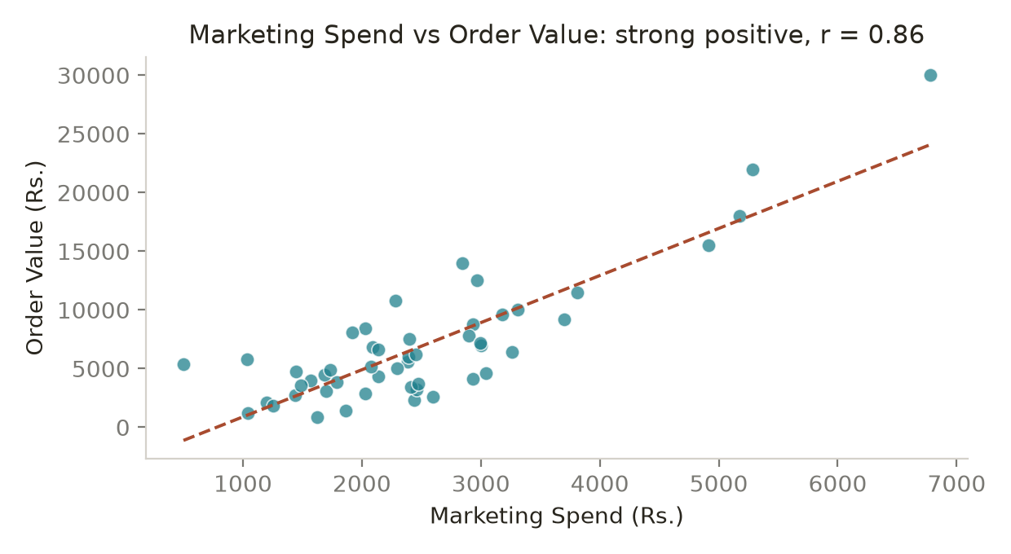
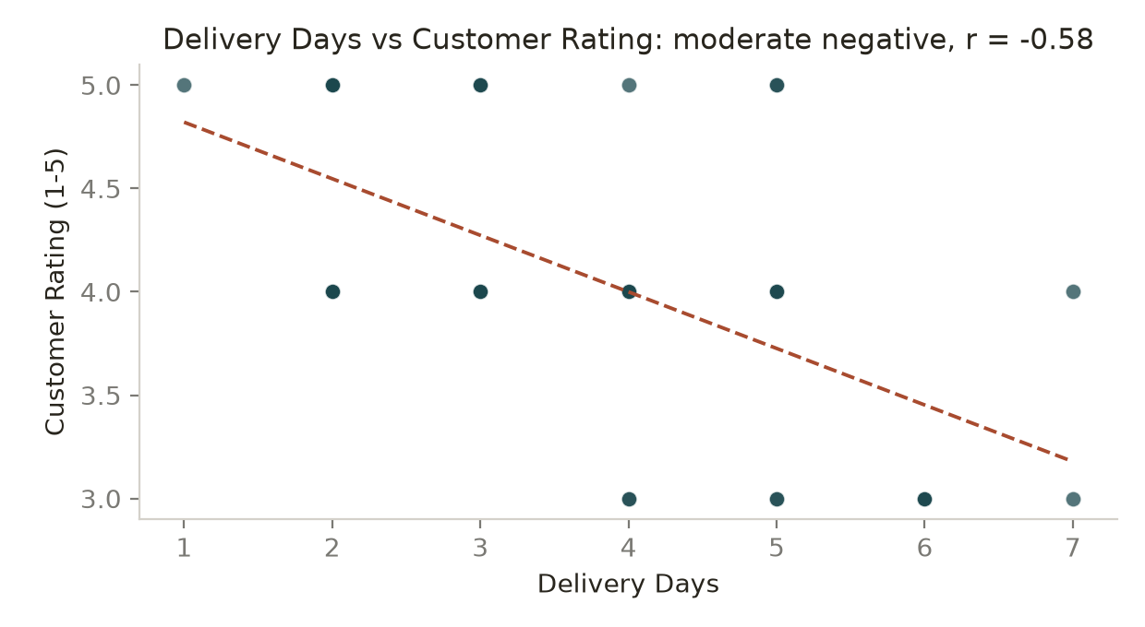
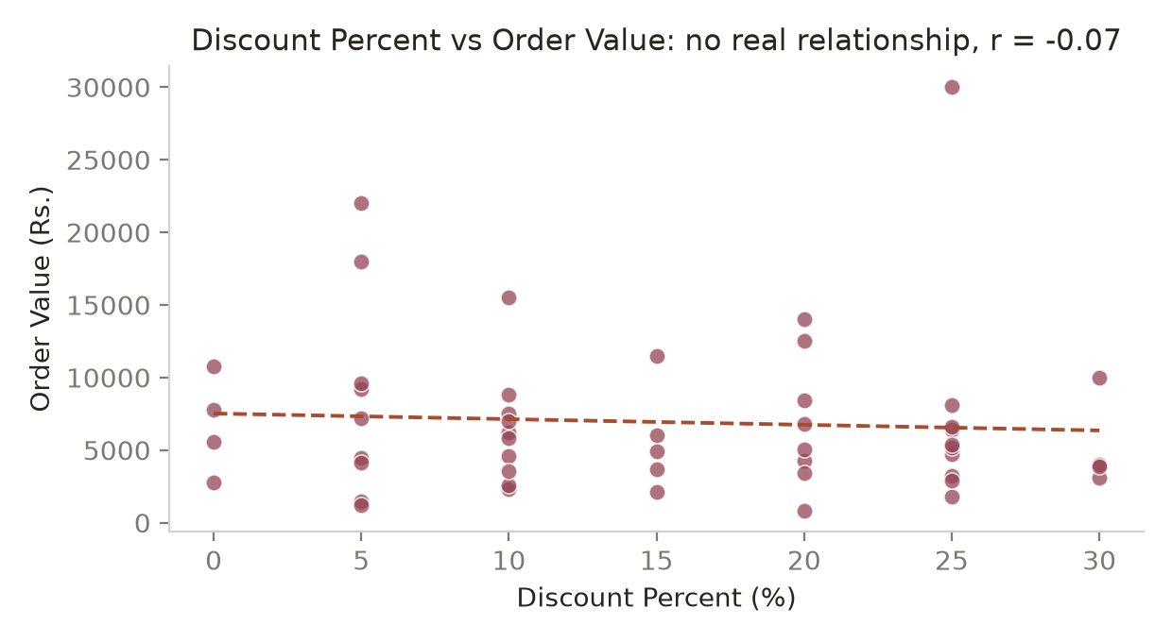
- Calculate correlation.
Answer: Pearson correlation coefficients (df[x].corr(df[y])):
• Marketing_Spend vs Order_Value: r = +0.857 (Spearman +0.662, p < 0.001)
• Delivery_Days vs Customer_Rating: r = −0.582 (Spearman −0.571, p < 0.001)
• Discount_Percent vs Order_Value: r = −0.066 (Spearman −0.119, p = 0.650)
- Identify the direction.
Answer: Direction of each relationship:
• Marketing_Spend vs Order_Value — positive: higher marketing spend goes with higher order value.
• Delivery_Days vs Customer_Rating — negative (inverse): the longer the delivery, the lower the rating.
• Discount_Percent vs Order_Value — very slightly negative, but statistically indistinguishable from zero, so effectively no direction.
- Comment on the strength.
Answer: Strength, using the usual bands (|r| ≥ 0.7 strong, 0.4–0.7 moderate, 0.2–0.4 weak, < 0.2 negligible):
• Marketing_Spend vs Order_Value — strong. r = 0.857 and r² = 0.735, so about 74% of the variation in order value is shared with marketing spend. Caution: this weakens to r = 0.595 (moderate) once the four outlier customers are removed, and Spearman is only 0.66, so the strength is partly driven by a few points.
• Delivery_Days vs Customer_Rating — moderate and highly significant (r² = 0.339, p < 0.001). Consistent across both Pearson and Spearman, so it is a stable pattern.
• Discount_Percent vs Order_Value — negligible. r² = 0.004 means discount depth explains under 1% of the variation in order value, and p = 0.65 means the result is indistinguishable from random noise.
- Interpret the relationship.
Answer: Interpretation of each:
• Marketing_Spend vs Order_Value — the two rise together very clearly: the four customers with the highest marketing spend (₹4,913–₹6,777) are also the four largest orders. But the most likely explanation is targeting, not persuasion — the company already directs more marketing at customers it knows are valuable. Reverse causality and confounding (category, loyalty, tenure) are both plausible, so this must be read as association only.
• Delivery_Days vs Customer_Rating — a credible operational relationship with a clear mechanism: waiting longer produces a worse experience. Average rating falls monotonically from 5.00 at 1 day and 4.64 at 2 days to 3.00 at 6 days. This is the relationship management can most defensibly act on, although a controlled improvement in delivery time would still be the proper proof.
• Discount_Percent vs Order_Value — no meaningful relationship. Deeper discounts are not associated with bigger baskets in this data, which suggests the discount budget may be subsidising purchases that would have happened anyway. It is also possible that discounts are applied to lower-priced categories, which would mask a real effect — worth testing rather than concluding.
- Check whether unusual observations could influence the relationship.
Answer: Yes, unusual observations clearly influence one of these relationships. Re-running the correlations on the 46 customers inside the ₹15,431.25 IQR boundary:
• Marketing_Spend vs Order_Value falls from r = +0.857 to r = +0.595 — from "strong" to "moderate". The four outliers (C004, C044, C007, C009) sit at the top-right of the scatter and act as high-leverage points that stretch the trend line, so roughly a third of the apparent strength comes from 8% of the rows.
• Discount_Percent vs Order_Value barely moves, from −0.066 to −0.054, confirming there is genuinely nothing there.
• Delivery_Days vs Customer_Rating is unaffected by order-value outliers, since neither variable contains extreme values (both are bounded: 1–7 days and 3–5 stars).
Diagnosis and handling: I checked the outliers rather than removing them — all four are internally consistent (12 items, high marketing spend, three are repeat customers), so they are genuine records. The right response is transparency, not deletion: report the correlation both with and without them, quote Spearman's rank correlation (+0.662), which is resistant to extremes, alongside Pearson, and note that with n = 50 a handful of influential points can move r substantially. Sensitivity analysis of this kind should accompany any correlation quoted to management.
Critical Question: If Marketing Spend and Order Value have a strong positive correlation, can you say “Increasing marketing spend causes order value to increase”? Explain why or why not.
Answer: No. A strong positive correlation of r = 0.857 does not license the statement "increasing marketing spend causes order value to increase." Correlation measures only that two variables move together; causation requires a mechanism, correct time ordering, and the elimination of alternative explanations.
Why the causal claim fails here:
1. Reverse causality — the far more likely direction is that high-value customers attract high marketing spend. Companies target their best customers, so Order_Value drives Marketing_Spend rather than the other way round. The four biggest spenders also received the four largest marketing budgets, which is exactly what targeting looks like.
2. Confounding variables — product category (electronics and appliances carry both larger baskets and bigger marketing budgets), customer income and purchasing power, loyalty and tenure, seasonality and festival campaigns, and channel mix could all drive both variables simultaneously.
3. No time ordering — the data is cross-sectional. There is no evidence that spend came before the order, and a cause must precede its effect.
4. Influential observations — r drops from 0.857 to 0.595 when the four outliers are excluded, so the headline strength is not robust; a relationship that depends on 4 of 50 rows should not be the basis of a budget decision.
5. Small, non-experimental sample — 50 observations, no control group, no randomisation, and possible selection effects in how customers entered the dataset.
6. Non-linearity and diminishing returns — even if some causal effect exists, r assumes a straight line, so it cannot tell management how much extra revenue an extra rupee of spend would generate, or at what point the return flattens.
What can legitimately be said: "Marketing spend and order value are strongly positively associated (r = 0.86, n = 50), largely because higher marketing investment is directed at higher-value customers. The association is weaker (r = 0.60) when four extreme customers are excluded."
How to establish causation: run a randomised controlled experiment — split comparable customers into treatment and control groups, vary marketing spend at random, hold everything else constant and measure the incremental difference in order value. Supporting approaches include geo-based holdout tests, incrementality/lift studies, marketing-mix modelling with time lags, and difference-in-differences analysis around campaign start dates. Until such a test is run, the honest framing is association, and the recommendation is to test before scaling budget.

16. Covariance
Calculate the covariance between Marketing_Spend and Order_Value.
Answer: Covariance(Marketing_Spend, Order_Value) = +5,433,311.78 (sample, ddof = 1). The population covariance, ddof = 0, is +5,324,645.54.
Computed as df[['Marketing_Spend','Order_Value']].cov().iloc[0,1], or equivalently np.cov(df.Marketing_Spend, df.Order_Value, ddof=1)[0,1]. The unit is rupees × rupees.
Cross-check: cov ÷ (sd_x × sd_y) = 5,433,311.78 ÷ (1,163.33 × 5,448.11) = 0.857, which reproduces the Pearson correlation exactly.
- Is covariance positive or negative?
Answer: Positive (+5,433,311.78).
- What does the sign tell you?
Answer: The positive sign means the two variables move in the same direction: customers with above-average marketing spend also tend to have above-average order value, and customers with below-average spend tend to have below-average order value. In other words the deviations from the two means share a sign more often than not. The sign is the reliable, interpretable part of a covariance — it tells you the direction of the linear association, and nothing more. A negative covariance would mean the variables move in opposite directions (as with Delivery_Days and Customer_Rating, whose covariance is −0.54), and a covariance near zero would mean no linear relationship.
- What does the magnitude tell you?
Answer: On its own, almost nothing useful. The magnitude of 5,433,311.78 looks enormous, but it is purely an artefact of the units and scale of the two variables — order values in thousands of rupees multiplied by marketing spend in thousands of rupees produces a number in the millions of "rupees squared". It does not mean the relationship is strong, and it has no upper limit against which to judge it. If Order_Value were re-expressed in lakhs, the same relationship would report a covariance of about 54.3; if it were converted to paise, the figure would run into billions — while the actual association would be completely unchanged at r = 0.857. Magnitude is therefore only comparable between variable pairs measured on identical scales, and the honest way to judge strength is to standardise it into a correlation.
- Why is covariance difficult to interpret by itself?
Answer: Because covariance is unbounded and unit-dependent, so it has no reference point.
• Its value can range from −∞ to +∞, so there is no benchmark that says whether 5.4 million is large or small.
• Its unit is the product of the two original units (₹ × ₹ here), which is not a quantity anyone can picture, and it is meaningless when the two variables have different units (days × stars).
• It changes whenever the measurement scale changes, even though the underlying relationship does not.
• It therefore cannot be compared across variable pairs: the covariance of Marketing_Spend with Order_Value (+5,433,311.78) and of Delivery_Days with Customer_Rating (−0.54) cannot be ranked against each other, even though the second relationship is a substantial one.
All covariance reliably conveys is the direction of the linear association.
- How does correlation make interpretation easier?
Answer: Correlation is standardised covariance — it divides the covariance by the product of the two standard deviations, r = cov(X,Y) / (σx × σy), which cancels the units and puts every relationship on the same −1 to +1 scale.
Here: 5,433,311.78 ÷ (1,163.33 × 5,448.11) = 0.857. That number can be judged immediately — 0.857 is a strong positive relationship, and it would stay 0.857 whether order value were recorded in rupees, lakhs or dollars.
The practical gains: (1) a fixed, bounded scale with clear interpretive bands; (2) unit-free, so it can be compared across completely different variable pairs — 0.857 for marketing vs order value against −0.582 for delivery days vs rating, which covariance could never let you rank; (3) squaring it gives r² = 0.735, the share of variance shared between the two variables, which is directly reportable to management; and (4) it can be tested for statistical significance (p < 0.001 here). Covariance is still the necessary building block — it supplies the direction and feeds the correlation formula, and it is used in portfolio theory and PCA — but for communication, correlation is what should be reported.
Business Question: If covariance between marketing spend and sales is positive, what does that suggest? What can you say, and what can you NOT say?
Answer: A positive covariance between marketing spend and sales suggests that the two move together: periods or customers with above-average marketing spend also tend to show above-average sales. That is a genuine and useful signal — it is consistent with marketing working, and it is what you would hope to see.
What I CAN say:
• The direction of the linear relationship is positive — higher marketing spend is associated with higher sales.
• The two variables are not independent; there is a systematic co-movement rather than random noise.
• The relationship is worth investigating further, and it justifies standardising the measure (r = 0.857 here, r² = 0.735) and testing it (p < 0.001).
What I CANNOT say:
• That marketing spend causes sales to increase. Covariance, like correlation, is association only. Reverse causality is highly plausible — budgets are often set as a percentage of expected or past sales, and spend is deliberately aimed at customers already known to be valuable.
• How strong the relationship is. The magnitude (5,433,311.78) is unit-dependent and unbounded, so it says nothing about strength until it is converted into a correlation.
• How much extra sales an extra rupee of spend would produce. That is a regression/elasticity question, and it would also require allowing for diminishing returns and time lags.
• That the relationship is free of confounding — seasonality, festival periods, price changes, competitor activity, product mix and distribution can all drive both variables at once.
• That it will hold in future, or at spend levels outside the observed range.
Correct framing for management: "Marketing spend and sales are positively associated. To establish whether additional spend actually generates incremental sales, we need a controlled test — a randomised or geo-holdout experiment, or an incrementality study — before increasing the budget."

Final Submission Requirements
- Python Notebook (.ipynb) containing calculations, NumPy implementation, sampling simulation, visualizations, correlation and covariance.
Prepared: Statistics_Data_Analytics_Analysis.ipynb, containing the data load and quality checks, all descriptive statistics, the NumPy implementation, the outlier analysis, the probability and conditional-probability calculations, the 100-iteration sampling simulation at n = 10 and n = 25, and the correlation and covariance analysis, each cell followed by a markdown interpretation.
- Business Analysis Report — maximum 3 pages.
Prepared: the management summary in section 14 above serves as the business analysis report. It runs to under 3 pages and covers spending centre and spread, distribution shape, outliers, customer behaviour, sampling, relationships, the correlation-vs-causation caution and two costed recommendations, each in Finding → Evidence → Interpretation → Business Implication form.
- Minimum visualizations: 1 histogram, 1 boxplot, 2 scatter plots and 1 sampling simulation visualization.
Included: 6 visualizations — 1 histogram of Order_Value with mean and median marked (section 6), 1 boxplot of Order_Value with the five-number summary and outliers annotated (section 6), 3 scatter plots with fitted trend lines for Marketing_Spend vs Order_Value, Delivery_Days vs Customer_Rating and Discount_Percent vs Order_Value (section 15), and 1 sampling-simulation histogram of 100 sample means comparing n = 10 with n = 25 (section 12). This exceeds the stated minimum of 1 histogram, 1 boxplot, 2 scatter plots and 1 sampling visualization.
- All major statistical results must include interpretation.
Complied: every statistical result above is followed by an interpretation stating what the number means and what the business should do about it — for example the mean/median gap is explained as right skew and translated into a reporting rule, and the −0.58 delivery-rating correlation is translated into a service-level target.
- Do not submit calculations without explanations.
Complied: no figure is presented without explanation. Formulae, degrees-of-freedom choices and percentile methods are stated so that each result is reproducible, and every calculation is followed by its business meaning.
- Do not make causal claims from correlation alone.
Complied: no causal claim is made anywhere from correlation alone. The Marketing_Spend – Order_Value relationship (r = 0.857) is explicitly flagged as association only, with reverse causality, confounding, absent time ordering, influential outliers and the small sample all set out, and a randomised experiment recommended before any budget decision.
- Do not remove outliers without investigating them.
Complied: the four outliers were investigated, not removed. Each was cross-checked against Items_Purchased, Marketing_Spend and Repeat_Customer, found to be internally consistent and therefore retained. Results are reported both with and without them (mean ₹6,939.00 vs ₹5,683.70; r = 0.857 vs 0.595) so the influence of those rows is fully transparent.

Evaluation Focus
- Correct application of statistical concepts.
- Correct calculations.
- Appropriate choice of statistical measure.
- Interpretation of results.
- Identification of sampling issues and bias.
- Distinguishing correlation from causation.
- Effective use of NumPy for statistical analysis.
- Ability to communicate findings in business language.
Calculate → Interpret → Question → Decide → Communicate

